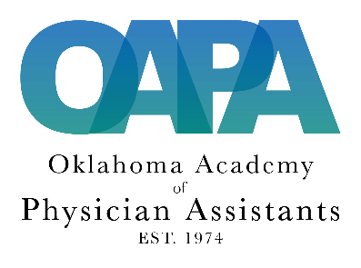

Oklahoma Academy of Physician Assistants

Certificate of Attendance

This certifies that

First Name:Click or tap here to enter text. Last Name: Click or tap here to enter text., PA-C

Earned ____________credits by attending the educational program
(Fill in the number of sessions you attended in the blank above)

ENTITLED

47th Annual CME Conference for Physician Assistants - Virtual
September 16 – December 31, 2020

This activity has been reviewed by the AAPA Review Panel and is compliant with AAPA CME Criteria. This activity is designated for 25 AAPA Category 1 CME credits. Approval is valid from 9/16/2020 to 12/31/2020. PAs should only claim credit commensurate with the extent of their participation. AAPA reference number CME-20118.

This program includes one hour of Category 1 CME on the topic of substance abuse as required by the Oklahoma Board of Medical Licensure and Supervision.

